Access s3 bucket from database server-

*Must read- to access any other services like s3 from ec2 instances we must have either gateway endpoint or server must exposed to internet using igw or nat.*

**Create a gateway endpoint**

Use the following procedure to create a gateway endpoint that connects to Amazon S3.

**To create a gateway endpoint using the console**

1. Open the Amazon VPC console at <https://console.aws.amazon.com/vpc/>

• .

• In the navigation pane, choose **Endpoints**.

• Choose **Create endpoint**.

• For **Service category**, choose **AWS services**.

• For **Services**, add the filter **Type: Gateway** and select **com.amazonaws.**region**.s3**.

• For **VPC**, select the VPC in which to create the endpoint.

• For **Route tables**, select the route tables to be used by the endpoint. We automatically add a route that points traffic destined for the service to the endpoint network interface.

• For **Policy**, select **Full access** to allow all operations by all principals on all resources over the VPC endpoint. Otherwise, select **Custom** to attach a VPC endpoint policy that controls the permissions that principals have to perform actions on resources over the VPC endpoint.

• (Optional) To add a tag, choose **Add new tag** and enter the tag key and the tag value.

• Choose **Create endpoint**.

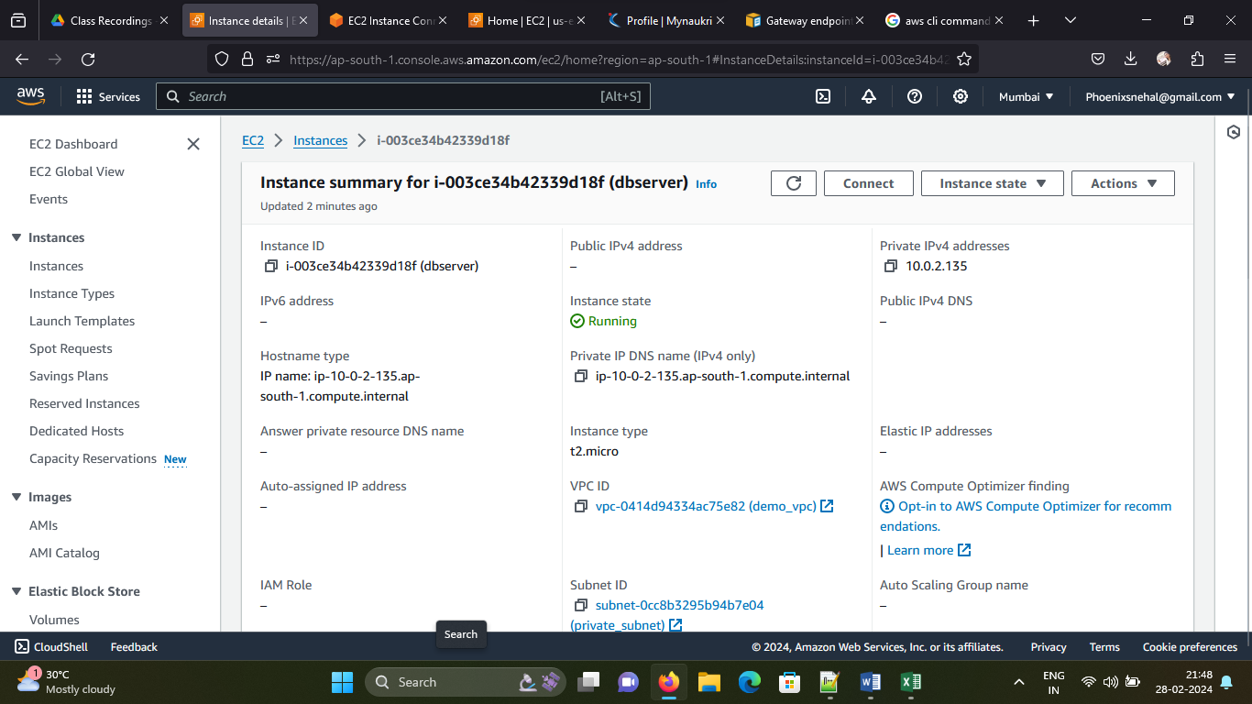

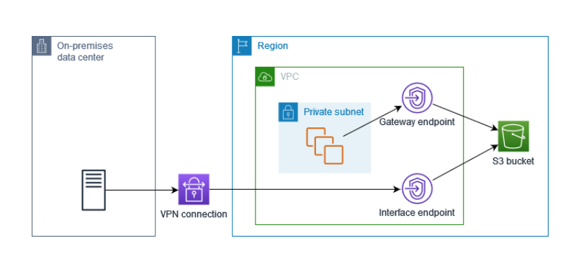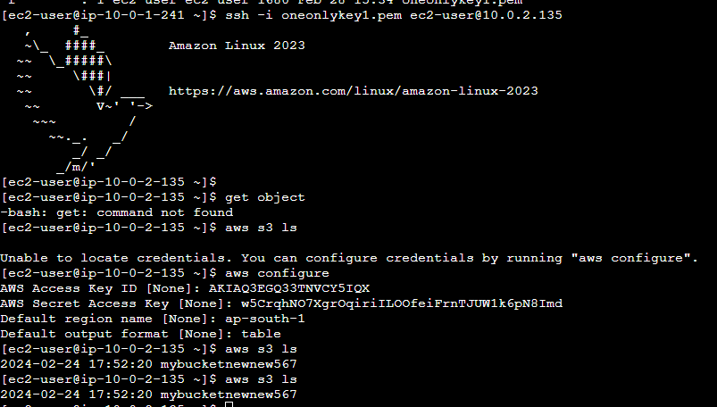

**copy an object from Amazon S3 to your instance—**

**requirement –**

**role and nat gateway**

**role + internet gateway**

aws s3 cp s3://my_bucket/my_folder/my_file.ext my_copied_file.ext

[https://docs.aws.amazon.com/AWSEC2/latest/UserGuide/AmazonS3.html ----link for s3](https://docs.aws.amazon.com/AWSEC2/latest/UserGuide/AmazonS3.html%20----link%20for%20s3) command

COMMANDS -

steps

1. vpc gateway end point

2. aws s3 ls

mkdir directoryname

aws s3 cp s3://bucketname/filename directoryname

cd directoryname

cat filename.txt

aws s3 cp s3://bucketname completepath --recursive

Not possible

create a IAM role, Attach s3 full access policy to the role. Attach that role to your DB-server.

And then try to connect your s3 buckets to read the files.

1. Created role attached s3 full access and also connected to ec2

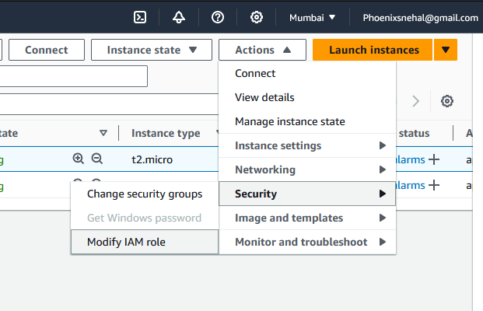

Not possible